

**North South University**

Department of Electrical & Computer Engineering

Project Proposal

**Summer 2024**

**Tittle**: A Web-Based Approach to Address Housing Issues for Employees and Bachelor Students

**Course No**: CSE 299 Sec: 1

**Faculty:** Dr. Mohammad Monirujjaman Khan

Members name & Id:

Ishtaik Ahmed Moyen Arnob Ahemd Isnat Hossain Rijon

2131580642 2211351642 2211203042

Contents Page no

1. Description of the problem being solved 1

2. Review of existing similar systems 1

3. Solutions adopted 2

4. Detailed diagrams for the complete system and all subsystems 2

5. Explanation of the functioning of the complete system and all subsystems 3

5.3. Back-end . . . . . . . . . . . . . . . . . . . . . . . . . . . . . . 3

5.4. Front-end . . . . . . . . . . . . . . . . . . . . . . . . . . . . . . 3

5.5. Tools/Software . . . . . . . . . . . . . . . . . . . . . . . . . . . 4

5.6. Deploy . . . . . . . . . . . . . . . . . . . . . . . . . . . 4

6. Gantt Chart

6. Diagrams & Database 4

7. Required software tools to complete the project 5

7.1. Costing . . . . . . . . . . . . . . . . . . . . . . . . . . . . . . . 4

7.2. Maintenance . . . . . . . . . . . . . . . . . . . . . . . . . . . . . 5

8. Gantt Chart 5

9. Steps you will follow to complete this project 6

10. Discussion 7

10. Bibliography 7

1. **Description of the problem being solved :**

The main problem being addressed is the lack of a centralized, well-organized platform that makes it easy for bachelors to locate suitable and reasonably priced homes. Because the current processes are disjointed, it takes too long for students and staff to look for temporary housing . Thousands of bachelors live in Dhaka and also all over Bangladesh for educational and professional purposes. They share flats and often 8 to 9 people live in a house. However, getting a flat with the ‘bachelor’ identity is not easy. Landlords often prefer to rent their houses to people who live with other family members to bachelors. Single tenants in the city share stories that sometimes landowners shut the door on them when they know that they are bachelor. Landlords also add to the stress and unfairness of the leasing process by enforcing rigid restrictions, big advance fees, and increased rents. We have created a web platform to handle these difficulties and make life easier. With the help of our platform, bachelors can locate lodging more easily and without having to deal with the typical prejudices and barriers that come with the traditional rental market. We remove the frustration of dealing with recalcitrant landlords by guaranteeing transparency and granting bachelors access to rental homes that are publicly available to them. In the end, our method seeks to eliminate housing discrimination in Dhaka by offering a quick, equitable, and stress-free way to locate rental properties.

1. **Review of existing similar systems:**

* **Bproperty.com[1]:**

**Feature:**

Starting back in 2016, Bpproperty has now become the only real estate solutions provider in Bangladesh and its largest transacting real estate company.

**Limitation:**

Not customized for Bachelor, and in the house picture, not standard; also only one picture they have that can't visualize the house picture.

* **THE TOLET.COM[2]:**

**Feature:**

The Tolet is an online-based effort to solve all the problems like Family, Bachelor, Office , Hostel, Sublet, Mess related to rent and which is also working as a part of the conviction to build a Digital Bangladesh. This company wants to give BANGLADESH a proper system to have house rent solution in digital way, without any broker issues**.**

**Limitation:**

1. The website has an improperly organized UI.
2. It is not possible to pick the location.
3. There's no filtering option available.

**3 .** **Solutions adopted:**

* 1. **User-Centric Interface**: Create an intuitive user interface that makes it simple for landlords and tenants to navigate. It should be possible for users to look for and narrow down their alternatives for accommodation by specifying things like location, rent, and extra services (like cleaning).
  2. **Enhanced Search Features:** Offer consumers the chance to refine properties based on pricing, the presence of shared accommodations, and other significant aspects like accessibility to public transportation, educational institutions, or places of employment.
  3. **Integrated Housekeeping Service:** Tenants will have the opportunity to reserve housekeeping services in addition to rental properties, which makes this platform one of a kind. For workers with hectic schedules or bachelors, this offers value and convenience.
  4. **Effective Property Listing System:** Make sure that owners of real estate have access to a streamlined and effective system for listing and managing their properties. This ensures that communications between owners and tenants go smoothly and includes simple uploads of property details, pricing, and availability.
  5. **Verification and Quality Assurance:** A system of property and user verification will be put in place to guarantee the veracity of listings. By doing this, the transaction is certain to provide both parties confidence.
  6. 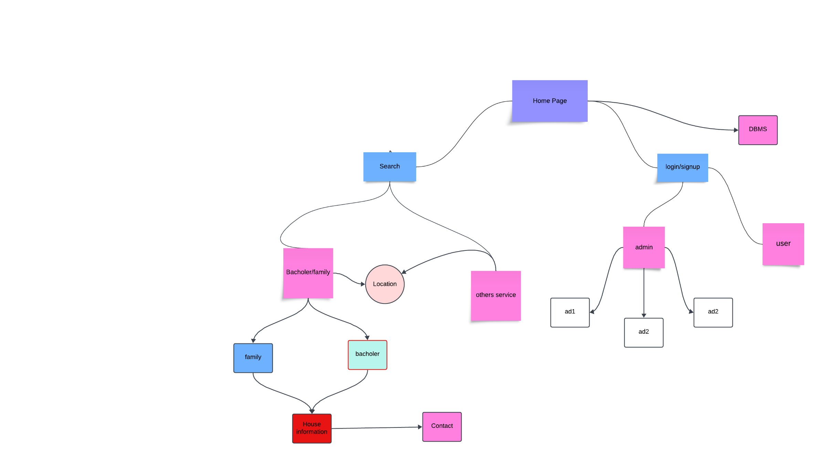**Scalable Architecture for Future Growth:** Construct the platform in a way that allows for future growth to include more cities and services. It should be possible to expand the application's user base and add new features.

**4.Detailed diagrams for the complete system and all subsystems:**

**Fig:** Diagrams for the complete system

**5.** **Explanation of the functioning of the complete system,and all subsystems:**

**Home Page:** The introductory page facilitating swift access to essential features.

**Search and Filtering Mechanism:** Search capability with multiple filters (e.g., budget, location, home type, amenities).

**Location-based search:** Users can pick neighborhoods in Dhaka.

**Tenant Classification:** Users may filter for accommodations suitable for bachelors or families.

Supplementary filters for services (e.g., housework, cleaning services).User Administration System:

**Login/Signup**: Account creation and user authentication.

**User Roles**: Separation of renters, landlords, and admin jobs.

**Profile Management**: For both tenants (preferences, saved listings) and landlords (properties, tenant history).

**Property Management System**: For Landlords: Adding and managing property listings, amending details.

**For Tenants**: Viewing available properties and selecting filters.

**House Information Subsystem:** Detailed property view, photographs, and virtual tours.

**Contact:** Option to contact the landlord and schedule viewings online.

**Service Scheduling and Management**: A subsystem where tenants can arrange services like housekeeping, maid help, and maintenance.

**Other Services:** Additional services that are adjustable dependent on property type.

**Service Fees**: Separate payment section for additional services like maid assistance.

**Admin and Moderation System**: Admin roles to handle listings, users, payments, and resolve disputes.

**Backend Dashboard**: Track user activity, manage complaints, and monitor property and payment listings.

**Search System**: The search system should query the database and apply filters (location, tenant type, services, pricing range) Database interaction to obtain the attributes satisfying the criteria.

**User Authentication & Role Management:** Admin accounts to monitor and control the platform.

Regular user accounts for tenants and landlords Session management, login/logout features, and OAuth connectivity if required.

**Property Management:** For Landlords: Add property, change details, and delete listings.

View tenant demands and contact them.

**For Tenants**: View property details, save searches, and bookmark properties ,Contact landlords through a secure message system.

**Other Service Integration:**

Tenants might request additional services (housekeeping, maid services).Real-time availability for these services based on location.

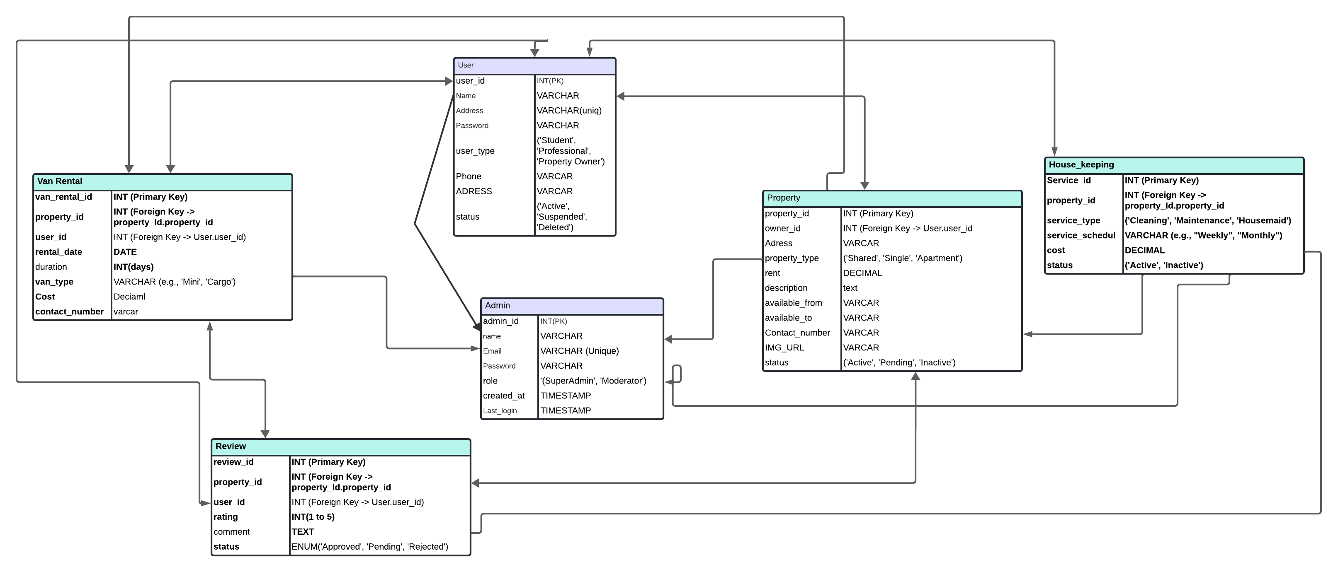**6. Diagrams** & **Database:**

**Fig:** ERD Diagrams

**7. Required software tools to complete the project :**

**7.1 collaboration:**

GitHub[3] will be used for the project collaboration. We have created a GitHub repository to work collaboratively and do version controlling easily.

**7.2. Back-end**

– PHP [4]

– Laravel [5]

– MySQL [6]

**7.3. Front-end**

– HTML5 [7]

– CSS[8]

– Javascript [9]

– ReactJS[10]

**8. Gantt Chart[11]:**

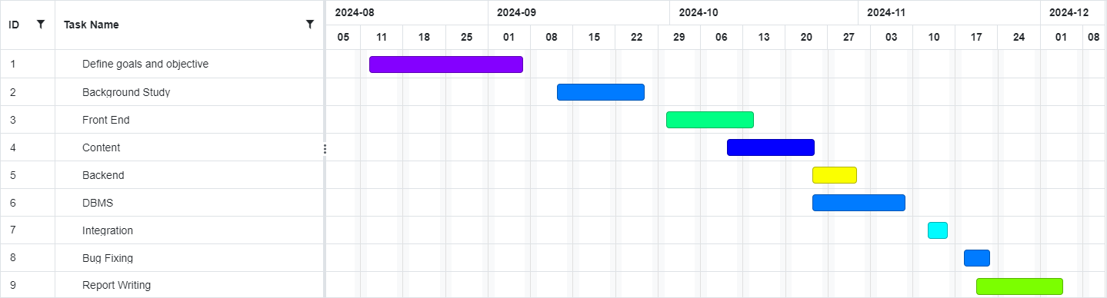

Fig: Gantt Chart

**9. Discussion :**

9.1. Costing:

|  |  |  |
| --- | --- | --- |
| ST | Cost Specification | TK |
| 1 | Web Hosting12 | $2 to $15/month |
| 2 | Database | $10 to $100+/month depending on database size and usage. |
| 3 | Development Costs | $10 to $500+/month depending on the complexity. |

9.2 Bug Fixing:

During the development and testing phases, several bugs were identified, including issues with filtering properties and payment integration. These were promptly addressed through rigorous testing and debugging, ensuring a smoother user experience and reliable functionality across the platform. Ongoing monitoring tools were also implemented to detect and resolve future bugs more efficiently.

9.3 Further Development and Maintenance:

The platform has a roadmap for further development, including plans to introduce mobile app versions, add features like user reviews and ratings, and optimize performance for increased user traffic. Regular maintenance cycles are scheduled to ensure the platform remains up-to-date with security patches, performance optimizations, and feature enhancements. Continuous user feedback will guide the refinement of both existing features and future upgrades.

**10. Bibliography :**

[1] Bproperty(2024,Sep,29).Bproperty[online] Avilable: https://www.bproperty.com/

[2] The Tolet (2024,Sep,29). ] The Tolet [online] Avilable: https://www.thetolet.com/

[4] PHP Documentation(2024,Sep,29). ] PHP[online] Avilable:: <https://www.php.net/docs.php>

[5]Laravel(2024,Sep,29). ] Laravel [online] Avilable:: <https://www.google.com/search?q=Laravel&rlz=1C1NDCM_enBD1050BD1050&oq=Laravel&gs_lcrp=EgZjaHJvbWUqBggAEEUYOzIGCAAQRRg70gEINDYzMmowajeoAgCwAgA&sourceid=chrome&ie=UTF-8>

[6] MySQL(2024,Sep,29). ] Mysql [online] Avilable: <https://www.mysql.com/>

[7]HTML (2024,Sep,29). ] Hypertext Markup Language [online] Avilable: https://www.w3schools.com/html/

[8]CSS5 (2024,Sep,29). ] Cascading Style Sheets [online] Avilable:https://www.w3schools.com/css/

[9] Javascript

[10]React.js Documentation (2024,Sep,29). ] JavaScript library [online] Avilable: <https://reactjs.org/docs/getting-started.html>

[11] Gantt chart (2024,Sep,29). ] Gantt chart [online] Avilable: <https://www.onlinegantt.com/#/gantt>

Stripe Payment API: <https://stripe.com/docs>

[12]AWS Hosting(2024,Sep,29). ] Amazon Web Services [online] Avilable: <https://aws.amazon.com>